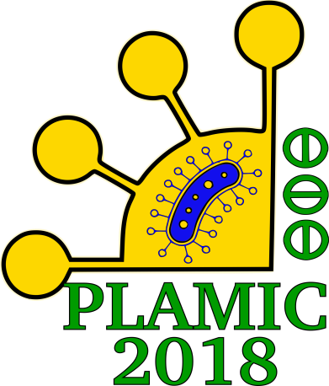
International Scientific Conference PLAMIC2018
«Plants and microbes: the future of biotechnology»
Russia, Ufa, 13-17 June 2018

The city of Ufa is located in the center of Russia, at the foot of Ural Mountains. It is famous for the mix of European and Asian cultures and delicious ethnic cuisine. Scientists and students from all over the world are welcome to our beautiful and modern city to discuss the latest achievements in the fields of:
1. Plant biotechnology, including micropropagation, in vitro cultures, genetic transformation, breeding, bioinformatics and phytoremediation.
2. Microbial biotechnology, including environmental and agricultural microbiology and bioinformatics
3. Plant-microbe symbiosis, including natural and artificial symbiotic systems: legume-rhizobium, actinorhizal and associative symbiosis, arbuscular mycorrhiza, сyanobacterial symbiosis, metagenomics and environmental biotechnology.
The event is organized by Russian Academy of Science.

Early registration fee is 50 euro for participants (including coffee breaks) and 20 euro for virtual participants with the presentation of e-poster. Please send an e-mail, titled “REGISTRATION”, with:
- Your name and job position (or class)
- Your department and organization with address
- The abstract title
- The type of participation (personal or virtual)
to PLAMIC2018@mail.ru until the end of January 2018.
You will receive the confirmation and further details about payment and abstract. Late registration is available for special charge.

It will be our pleasure to help you organize your trip, including flights and accommodation. For the information you can write to
PLAMIC2018@mail.ru
mikhele@list.ru
zilyaver@mail.ru

